1. Create a visualisation showing the Sales of EU, JP, NA, Global and Other plotted against Year of release.

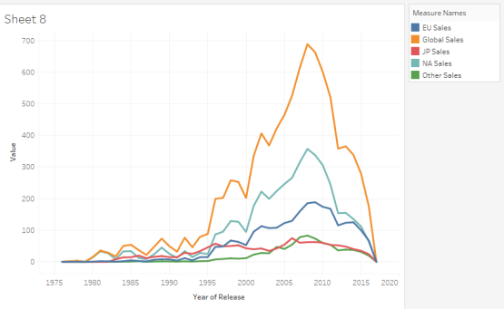

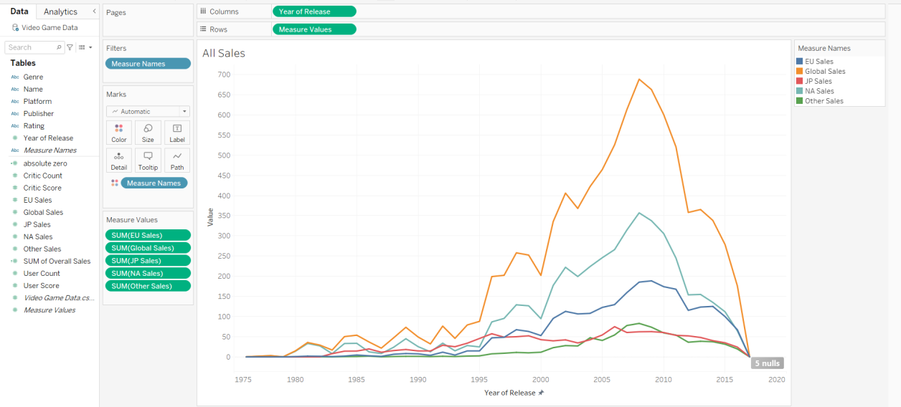  
  
How to get final result:  
I moved Years of Release into the Columns and Measure Values into the Rows. In the filters I filtered Measure Names to display only EU Sales, Global Sales, JP Sales, NA Sales, and Other Sales. I added Measure Names to the color mark.

1. Create a Donut chart showing Percentage of JP sales for different genres. Show the total JP sales in the middle of the donut.

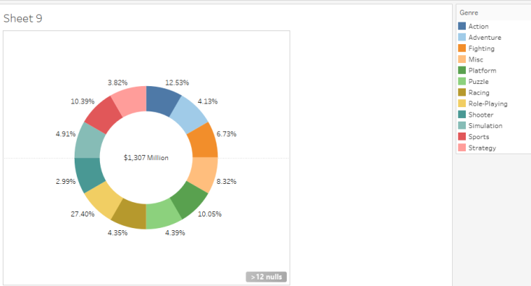

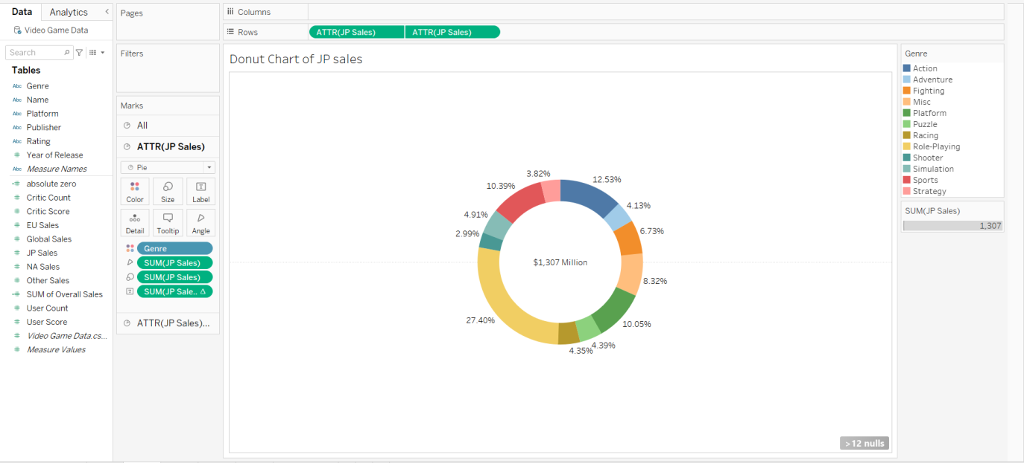

How to get final result:

I added JP Sales into rows twice. I then changed both to the chart type of Pie in their respective marks.  
In the one circle I added Genre to color, SUM(JP Sales) to angle, SUM(JP Sales) to Size, and SUM(JP Sales) to label. The label one I right clicked and changed the quick table calculation to percentage of total.   
  
In the 2nd circle I added the SUM(JP Sales) and changed the background color to white. Inside the label I also changed it to add the $ and Million before and after the SUM(JP Sales) value. I also changed the size of the circle to be a bit smaller than the other one.  
  
Once both of those were complete I right clicked on the one ATTR(JP Sales) in the row section and selected dual axis.

1. Create a calculated field that adds the Sales of EU, JP, NA, Global and Other. Use this calculated field to create the following visualisation.

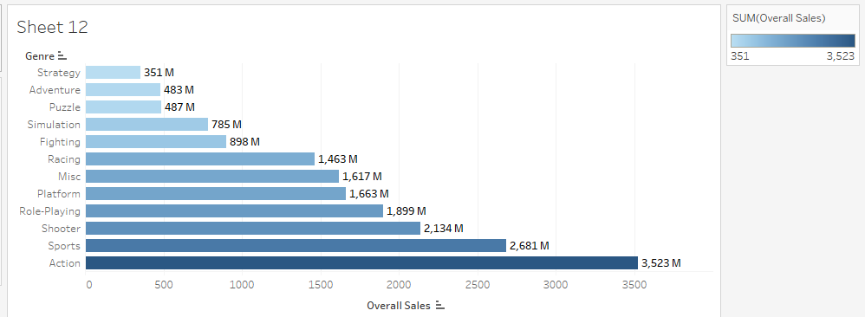

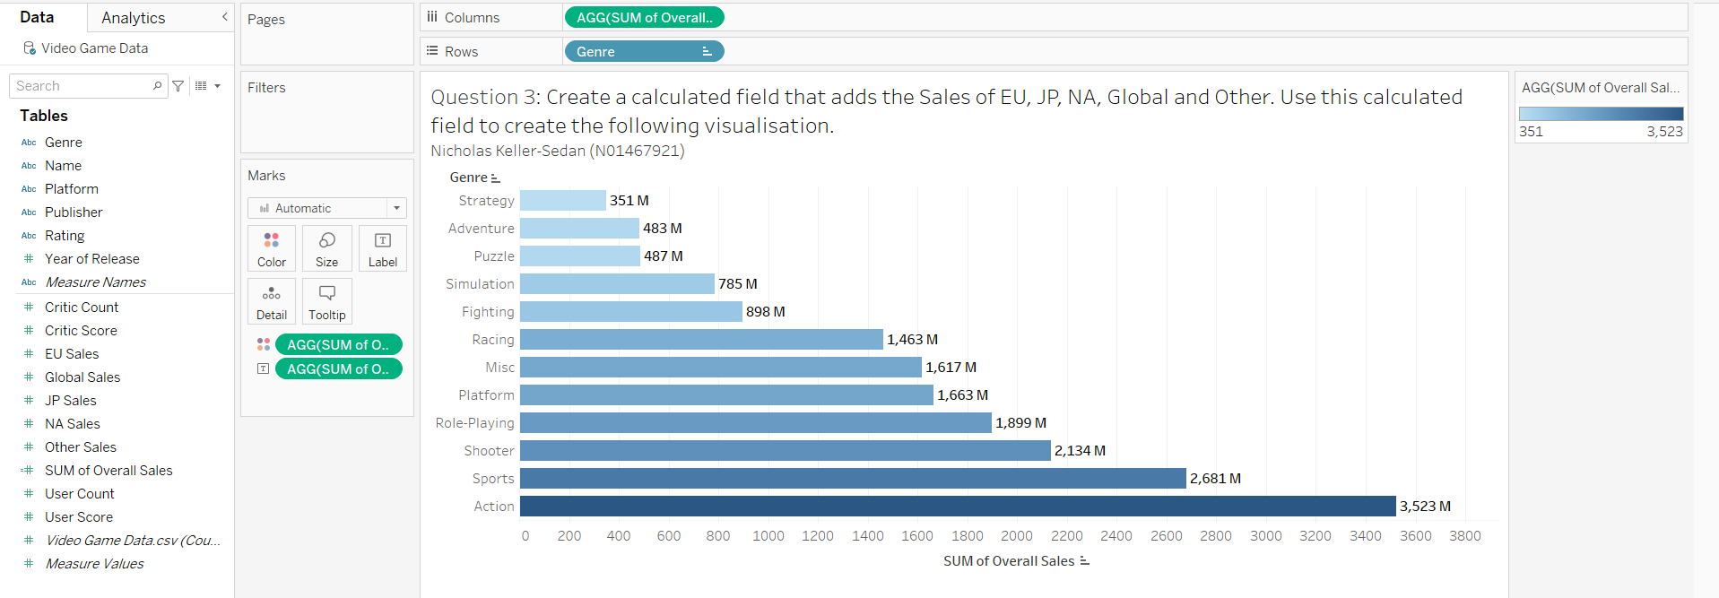

How to get final result:  
I created a calculated field called SUM of Overall Sales with the calculation below.  
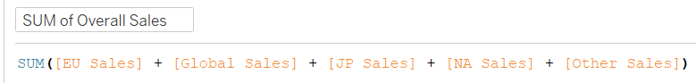  
I then used that new field and put it in the columns. I added genre to the rows. I added the created calculated field to the color mark and left it as automatic for the blue range of color. I added the created calculated field to the label and made it bold and added an M after the text.

1. Create the following visualisation showing the summary of various measures.

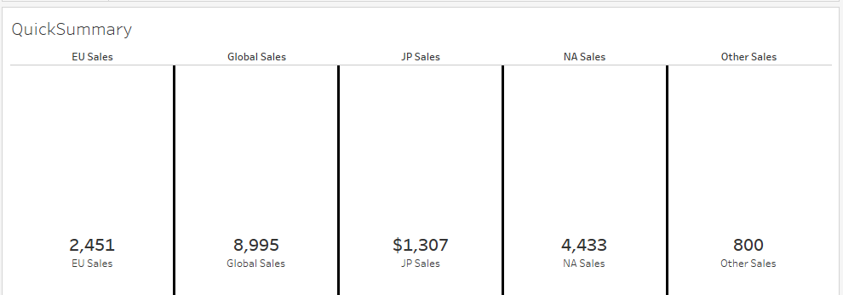

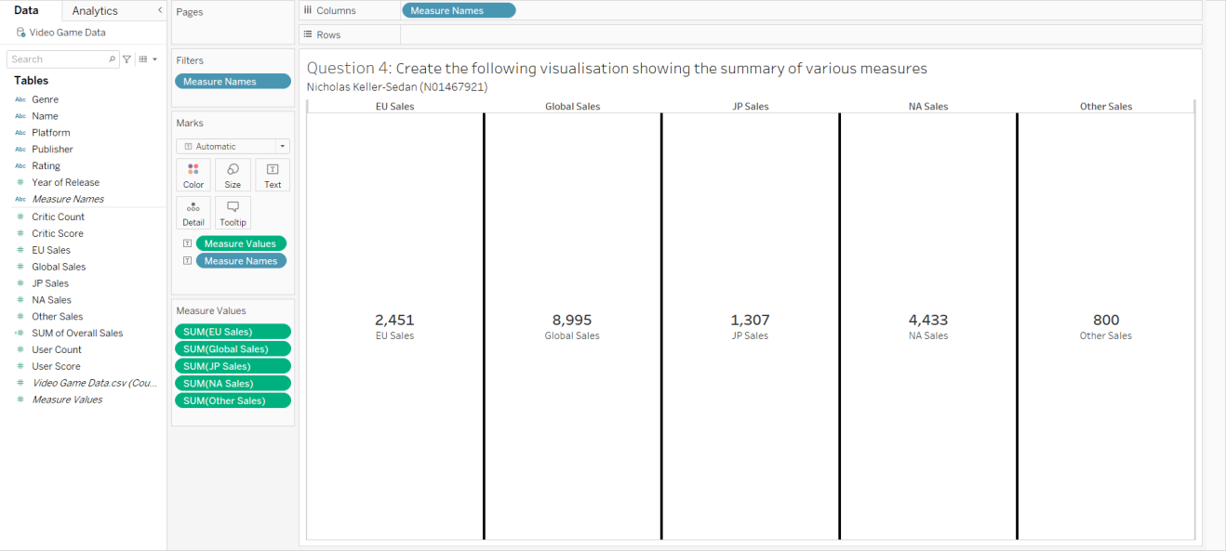  
How to get final result:

I added the measure names to columns. I then filtered the Measure Names to only the sales (NA, EU, Global, JP, and Other). I then added the Measure Values and Measure Names into text in the marks section. I made the Measure Values bold and made it centered under the text options. I then went into Format Shading and clicked on Rows. I changed the Pane and Header to a light grey. For the Columns I changed the Divider Cell to black and a thicker line  
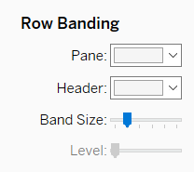 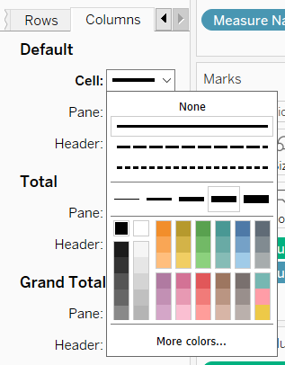

1. Create a butterfly chart to compare the User and Critic scores. You can use different colors if you want.

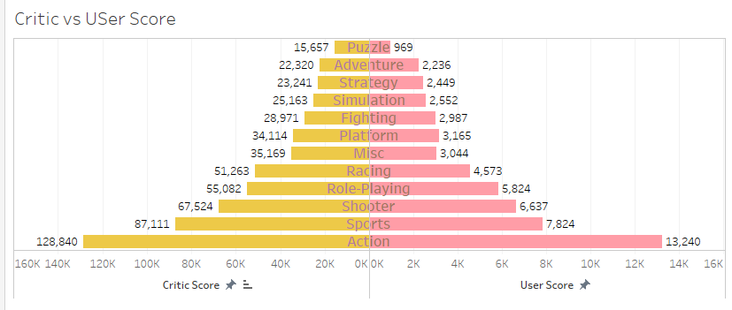

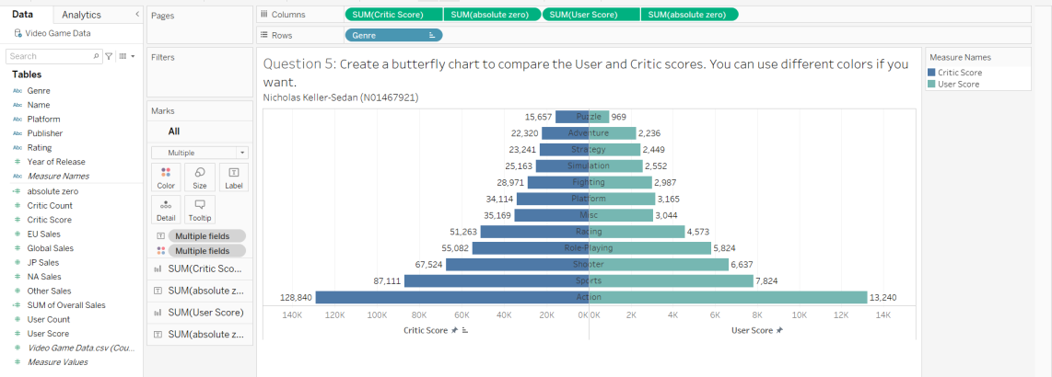  
How to get final result:

I added SUM(Critic Score) and SUM(User Score) to Columns and Genre to Rows. I added Measure Names into the color mark for the critic and user scores. I added the respective score into each label of the marks (user to user and critic to critic). I then created a calculated field called absolute zero. I moved that in between the two score in the columns. I added Genre into the text for absolute zero. I changed the chart type to text. I double clicked on the Critic Scores and changed it to Reversed scaling. I edited the absolute zero axis to remove the title. I then right clicked on the absolute zero in the columns and selected dual axis. I changed the default chart types of user and critic scores back to bar since it changed on its own. I right clicked on the critic axis and clicked synchronize axis. and then double clicked the critic axis and changed it to range fixed at a start of 0 and the end to automatic. I then added another absolute zero after user scores in columns. I added genre as the text in the mark pane for this one and changed it to a chart type of text like the previous one. I clicked on the new absolute zero and selected dual axis. I then right clicked on the user score and selected synchronize axis. I then double clicked on the user score axis and changed the range to fixed and the fixed start to 0 and the end to automatic. I then sorted it in ascending order by critic score.  
